# **Assignment 3 (Benchmark)**

1. **Output (Snapshot of Code output in the terminal)**

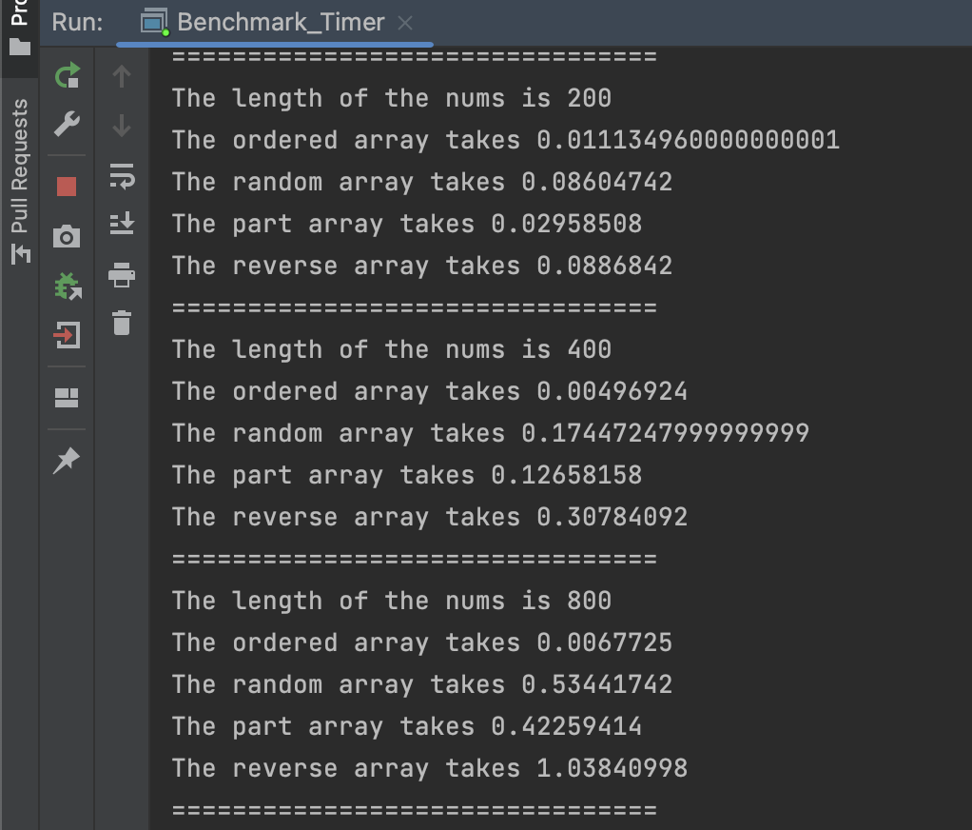

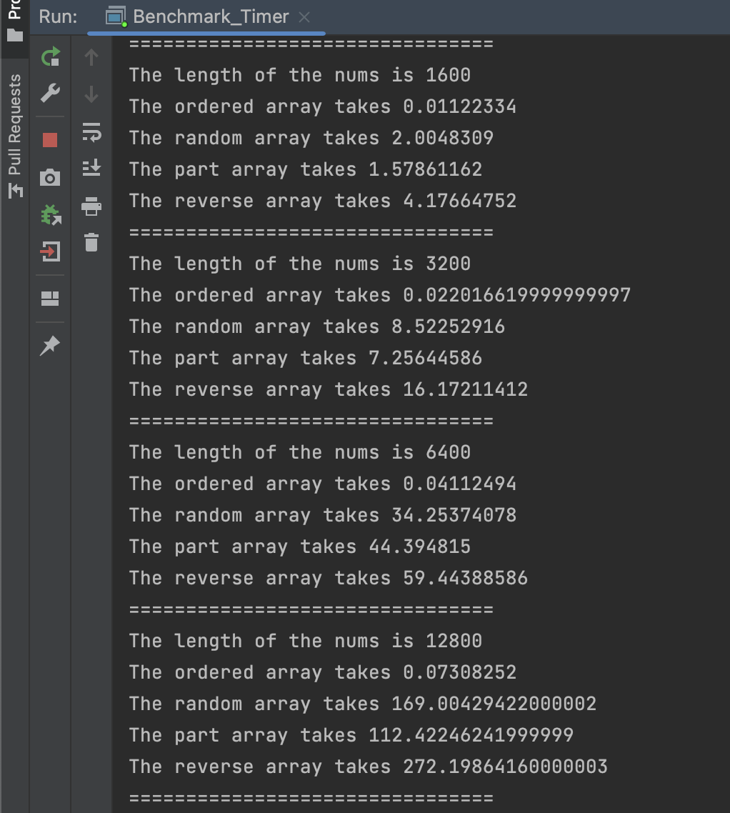

**Relationship Conclusion：**

The time required to sort the four arrays from small to large is：

The ordered array, The random array, The partial ordered array, The reserved array

The fewer numbers in order, the longer it takes.

The time complexity of ordered array is O(n).

The time complexity of sorting a random array / reversed array / partial ordered array would be O(n^2).

1. **Unit tests (Snapshot)**



